

May 2nd, 2016

**Rep Alert – Calibration Bath promotion**

Dear Sales Partner,

Please find below all the details on a promotion with the Fluke Calibration Baths.

**Customer promotion**

**Buy a Fluke Calibration Bath and get up to 10% of its value in fluid**

**Time frame**:   
April 25th – December 31st, 2016



**How to promote:**

* Promotional webpage and banner on FCAL website:   
  [http://eu.flukecal.com/](http://eu.flukecal.com/free-probe-with-metrology-well)node/93752  
  <http://eu.flukecal.com/de/node/94547>

<http://eu.flukecal.com/fr/node/94548>  
<http://eu.flukecal.com/es/node/94549>

<http://ru.flukecal.com/node/94550>

* 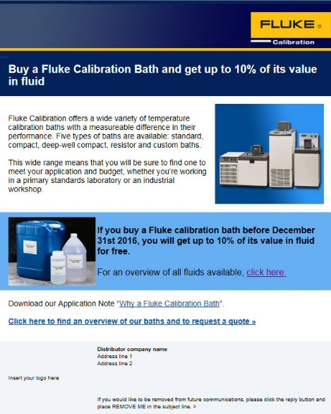Promotional banner on distributors’ websites.  
  If you need the banner in local language or in a different size, please contact gerda.meijer@flukecal.com
* Html mail to end customers  
  Please send to your own customer database

### How to order: Receive 10% of the bath value as maximum discount on your fluid purchase.

### Example 1:

### Bath price is EUR 8000.

Selected fluids amount up to EUR 1000  
Add discount of EUR 800 (=10% of 8000)

Example 2:

### Bath price is EUR 10.000.

Selected fluids amount up to EUR 900  
Add discount of 900 EUR, so fluids are for free (the discount is calculated on the fluids)

### Place your order with the text BATH-FLUID-PROMO

With kind regards,

EMEA Fluke Calibration Team